ST. JOHN’S JOURNAL
OCTOBER NEWSLETTER
St John’s Lutheran Church
404 Jefferson St.
Rochester, IN 46975
574-223-6898
Pastor Curtis May
574-835-8355
FACEBOOK: www.facebook.com/stjohnschurchlcms
WEBSITE: www.stjohns-churchlcms.org
WHAT’S HAPPENING AT
ST. JOHN’S

Dairy Queen Night, Oct 2nd 4-10

Fish Fry, Oct 3rd 4:30-7:30

Chili Cook off October 12th, 7 AM To?

Trunk or Treat 5-? Here at the Church

Prayer Walk, Sun Oct 20th after Late Church, 12:00 PM

Sacrificial Sunday, Oct 27th

We Give Thee But Thine Own…
Do you remember that old hymn? When I was a child we sang that during the offering every Sunday. We give Thee but thine own whatever the gift may be. All that we have is thine alone, a Trust O Lord from Thee. Is it God’s or is it ours? I think of this every Harvest time especially. A TRUST O LORD FROM THEE.
Each man should give what he has decided in his heart to give, not reluctantly or under compulsion, for God loves a cheerful giver. 2nd Corinthians 9:7
Junette Price: Editor
LIBRARY NEWS:
Just a quick note that there are some coffee table books in the Library that you might want to check out: The 12 Brides of Christmas and 30 days to understanding the Bible. Enjoy our many new additions to our Library!
PASTOR’S PAGE “Getting Excited Part 4”
Luke 14:13–14 . ¹³But when you give a feast, invite the poor, the crippled, the lame, the blind, ¹⁴and you will be blessed, because they cannot repay you. You will be repaid at the resurrection of the just.”
I want it and I want it now; these words echo across a nation and even across the world. Generations full of impatient children expecting their reward that they feel is owed to them and impetuously wondering why they haven’t received it yet. We should all be lavishly rich; we should all have what “we” want when we want it.
We don’t care about what God says about loving our neighbor unless it makes us look good, after all we all have a our needs and a reputation to portray. What does God mean I have to wait for my reward at the time of resurrection? Everybody knows waiting always takes an eternity, we want it now. And while you’re at it give me my resurrection now too.
Ok, maybe we are not all this severe, truthfully we are all somewhat impatient at times, and we all wish we could have it all now. The more the world shows itself through the many forms of media, the more our world portrays itself as an impetuous impatient child.
Waiting seems like an eternity in this short life we live in on this world our God has created for us. However, we fail to consider that this life is very short compared to eternity. Yet, we strive to have it all now, we fail to see what we have and then fail to appreciate it.
This is worth getting excited about. God has given us a feast and invites us to share in that feast with those who are poor, crippled, lame, blind, deaf, challenged, and unable at times to come to the feast table. What God has given us is in fact is really meant for everyone; the fortunate and the unfortunate, the patient and the impatient.
Hebrews 13:1–2 ¹Let brotherly love continue. ²Do not neglect to show hospitality to strangers, for thereby some have entertained angels unawares.
Do you believe in angels? Do you think they could be among us, and do you think that God just might be using them as His eyes and ears? We may never know when we have seen one of God’s angels because they are not here for their glory, but rather to share in the glory that belongs to God. What we do not expect is what we sometimes receive; sometimes we receive our rewards more when we do not expect them. Do not expect to receive a reward and you may see when it is given to you, expect it and you miss seeing it altogether.
Matthew 6:1-2 ¹ “Beware of practicing your righteousness before other people in order to be seen by them, for then you will have no reward from your Father who is in heaven.
² “Thus, when you give to the needy, sound no trumpet before you, as the hypocrites do in the synagogues and in the streets, that they may be praised by others. Truly, I say to you, they have received their reward.
Luke 6:35 ³⁵ But love your enemies, and do good, and lend, expecting nothing in return, and your reward will be great, and you will be sons of the Most High, for he is kind to the ungrateful and the evil.
Proverbs 19:17 ¹⁷Whoever is generous to the poor lends to the Lord, and he will repay him for his deed.
There are rewards in this life given to us by God, even the reward we receive from those expressions on the faces of those whom we have helped or shared with. It is exciting and something to be excited about, for what we can be excited about and share can also be our salvation.
Yes, we will wait to be repaid when the resurrection Jesus Christ had told us about, but it is really going to happen. We can wait for the joy of our reward, that is God’s will for our eternity. This is exciting.
Hebrews 13:7–17 ⁷Remember your leaders, those who spoke to you the word of God. Consider the outcome of their way of life, and imitate their faith. ⁸Jesus Christ is the same yesterday and today and forever. ⁹Do not be led away by diverse and strange teachings, for it is good for the heart to be strengthened by grace, not by foods, which have not benefited those devoted to them.
Our never changing savior Jesus Christ, did not suffer humility, pain and death in vain. Rather, He suffered all for all for the sake of His Father’s will. Our Father in heaven, our Lord Jesus Christ our Savior, and the Holy Spirit are not only the one true God, but all have the one true will. The will of God is to save His creation whom He loves dearly. We are that creation God loves, and though we are ungrateful He still loves us. This is exciting, He, our God, loves us so much He wants a relationship with us for all eternity. Amen.

Mike Wachtmann, 10/3
Sandra Sutton, 10/7
Susan Jaeger, 10/9
Mike Holliger, 10/10
Deborah Sears, 10/18
Anita May, 10/20
Sharon Mills, 10/20
Dennis Jaeger, 10/28
Augie Bair, 10/29
Jane Irwin, 10/31
WHAT GOD SAYS ABOUT COMMUNION/THE LORDS SUPPER
^{John 6:52-58 ESV}
⁵² The Jews then disputed among themselves, saying, “How can this man give us his flesh to eat?” ⁵³ So Jesus said to them, “Truly, truly, I say to you, unless you eat the flesh of the Son of Man and drink his blood, you have no life in you. ⁵⁴ Whoever feeds on my flesh and drinks my blood has eternal life, and I will raise him up on the last day. ⁵⁵ For my flesh is true food, and my blood is true drink. ⁵⁶ Whoever feeds on my flesh and drinks my blood abides in me, and I in him. ⁵⁷ As the living Father sent me, and I live because of the Father, so whoever feeds on me, he also will live because of me. ⁵⁸ This is the bread that came down from heaven, not like the bread the fathers ate and died. Whoever feeds on this bread will live forever.”
1 Corinthians 11:23-32 ESV
²³ For I received from the Lord what I also delivered to you, that the Lord Jesus on the night when he was betrayed took bread, ²⁴ and when he had given thanks, he broke it, and said, “This is my body which is for you. Do this in remembrance of me.” ²⁵ In the same way also he took the cup, after supper, saying, “This cup is the new covenant in my blood. Do this, as often as you drink it, in remembrance of me.” ²⁶ For as often as you eat this bread and drink the cup, you proclaim the Lord’s death until he comes.
²⁷ Whoever, therefore, eats the bread or drinks the cup of the Lord in an unworthy manner will be guilty concerning the body and blood of the Lord. ²⁸ Let a person examine himself, then, and so eat of the bread and drink of the cup. ²⁹ For anyone who eats and drinks without discerning the body eats and drinks judgment on himself. ³⁰ That is why many of you are weak and ill, and some have died. ³¹ But if we judged ourselves truly, we would not be judged. ³² But when we are judged by the Lord, we are disciplined so that we may not be condemned along with the world.
Matthew 26:28 ESV
²⁸ for this is my blood of the covenant, which is poured out for many for the forgiveness of sins.
Most people think that the Lords Supper is sharing a meal with our Lord Jesus. After you have read “What God says about communion,” I hope you now believe you are having a meal of our Lord Jesus who gave His Body and Blood to be food of forgiveness and remembrance of how and why Jesus Christ gave up His Body and Blood for us.
Our Lord Jesus Christ did not die on the cross to just give us food and drink. Christ gave Himself up to suffering and dying on the cross to forgive all of our sins. And this, Christ did out of the love of our God who brings salvation to all whom He calls. Though God calls all to be His adopted children, only those who listen to the Holy Spirit and believe will inherit eternal life. One also has to realize that eternal life is also eternal relationship with our benevolent and loving God.
The question that most people have is, “Why cannot everybody take communion?” First realize that one does not need communion to be saved and have eternal life and relationship with our Lord Jesus Christ. There are serious qualifications in God’s word before one can take the Lord’s Supper. Again Read “What God says about communion.”
These qualifications are why we (LCMS) have Catechism for our youth, new members who do not know Christ, and new members who come from different denominations. Not all denominations teach correctly the seriousness of taking the true body and blood of our Lord and Savior.
Without the proper knowledge and teaching of the Lord’s Supper we would be allowing people to take it to their judgement. This is not in our hearts to see one be judged. This also brings judgement upon the pastor serving the Lord’s Supper.
James 3:1 ESV Not many of you should become teachers, my brothers, for you know that we who teach will be judged with greater strictness.
This is not about us or you, but rather about what our God wants for all believers.
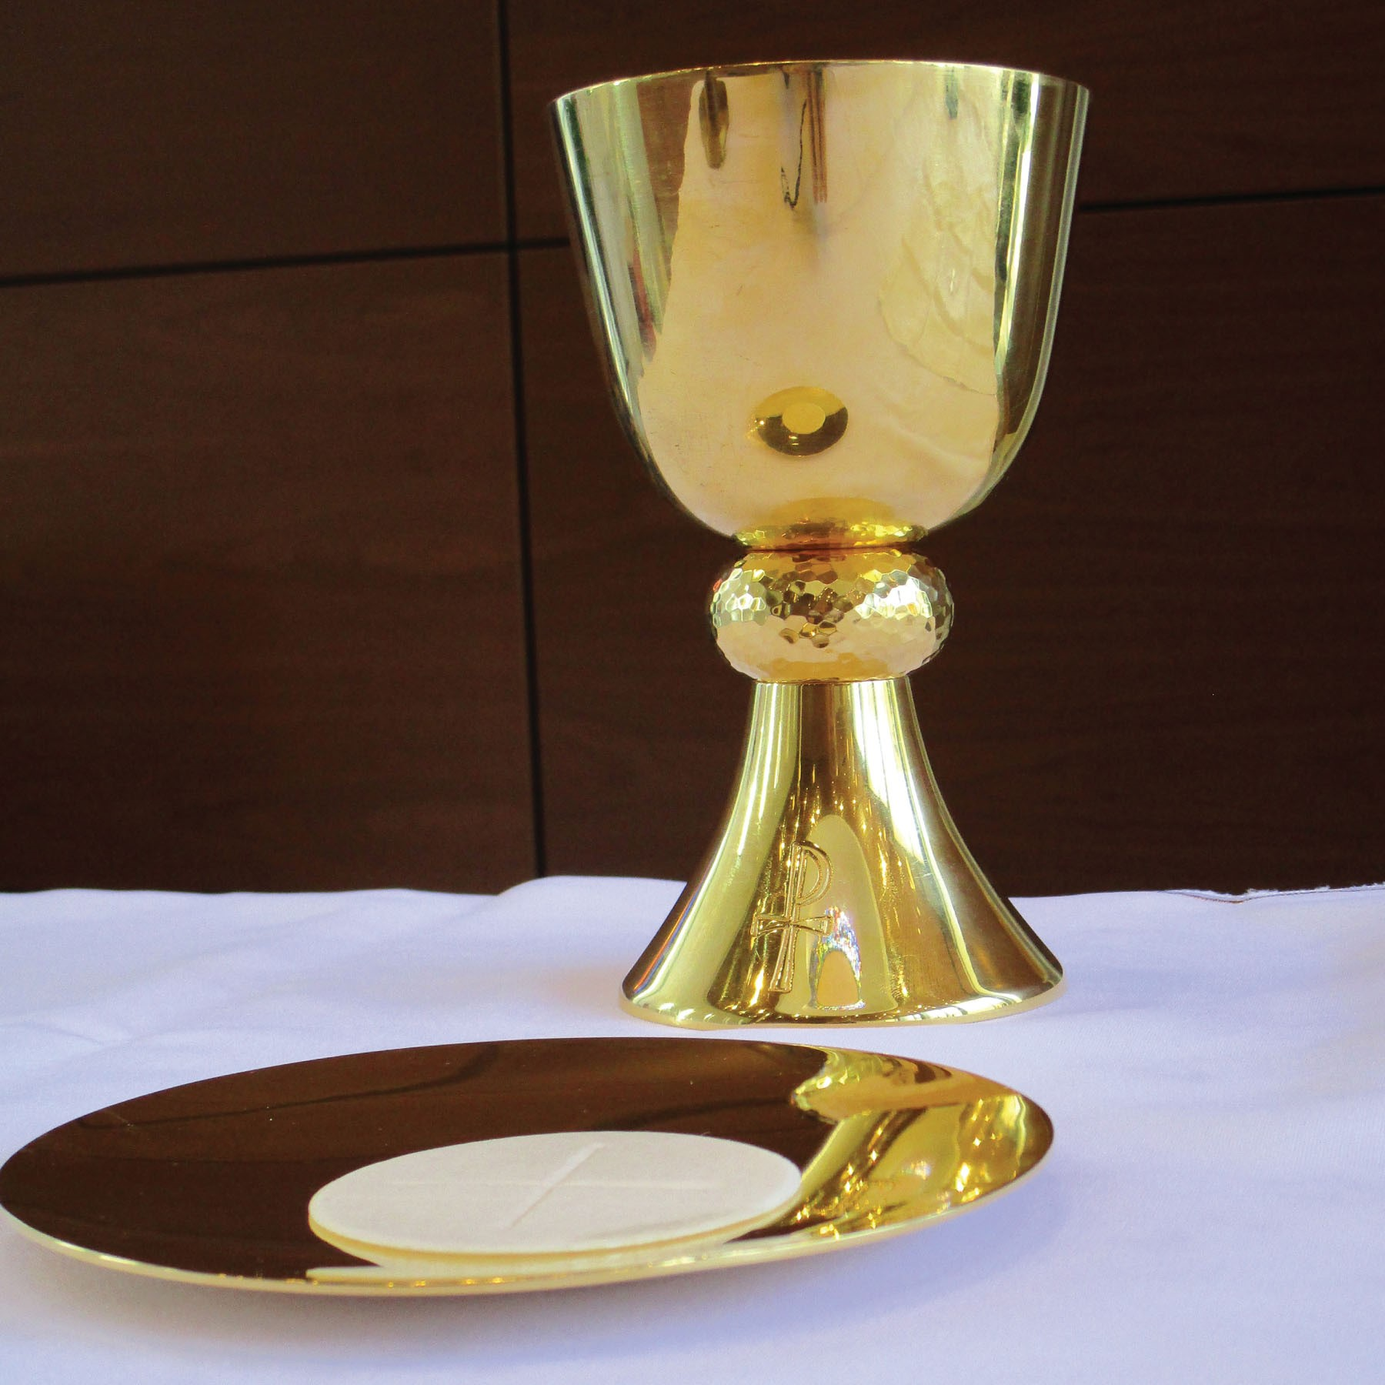
John 3:17 ESV ¹⁷ For God did not send his Son into the world to condemn the world, but in order that the world might be saved through him.

October
2019
Sunday | Monday | Tuesday | Wednesday | Thursday | Friday | Saturday
 |  | 1 | 2 | 3 | 4 | 5
 |  | LWML 1:30 PM  CELEBRATE  RECOVERY  5:30 TO 8 PM | DAIRY QUEEN NIGHT 4-10 PM  WOMEN’S STUDY 5 PM | FISH FRY, 4:30-7:30 PM  NO LIFE LESSONS |  | MEN’S STUDY  9 AM
6 | 7 | 8 | 9 | 10 |  | 12
CONTEMPORARY  8:00 AM  SS/BIBLE 9:15 AM  TRADITIONAL  10:30 AM | ELDERS  6:00 PM | CELEBRATE  RECOVERY  5:30 TO 8 PM | WOMEN’S STUDY 5 PM | LIFE LESSONS  4-6 PM  EVANGELISM 6  COMM/TECH 6:30  ED BOARD 7 PM
13 | 14 | 15 | 16 | 17 | 18 | 19
CONTEMPORARY  8:00 AM  SS/BIBLE 9:15 AM  TRADITIONAL  10:30 AM | TRUSTEES 5 PM  FINANCE 6 PM  COLUMBARIUM  7 PM | CELEBRATE  RECOVERY  5:30 TO 8 PM | WOMEN’S STUDY 5 PM | LIFE LESSONS  4-6 PM  SALVATION ARMY 4:30 PM |  | MEN’S STUDY  9 AM
20 | 21 | 22 | 23 | 24 | 25 | 26
CONTEMPORARY  8:00 AM  SS/BIBLE 9:15 AM  TRADITIONAL  10:30 AM |  | CELEBRATE  RECOVERY  5:30 TO 8 PM | WOMEN’S STUDY 5 PM | LIFE LESSONS  4-6 PM
27 | 28 | 29 | 30 | 31
CONTEMPORARY  8:00 AM  SS/BIBLE 9:15 AM  TRADITIONAL  10:30 AM |  | CELEBRATE  RECOVERY  5:30 TO 8 PM | WOMEN’S STUDY 5 PM | TRUNK OR TREAT 5-?  NO LIFE LESSONS |  | 1ST & 3RD  SUNDAYS ARE  COMMUNION  SUNDAYS

